Press Release

Rennes, 22 October 2012

The translation agency LinguaForce has put its linguistic skills at the disposal of the German architectural studio Kuehn-Malvezzi for the installation “Komuna Fundamento” presented during the 13th International Architecture Exhibition “Common Ground” which takes place as part of the Venice Biennale until the 25th November 2012.

LinguaForce, a translation agency which has been in business in Rennes (France) since 2005, has just completed an impressive translation into Esperanto for the installation “Komuna Fundamento” as part of the Venice Biennale. On this occasion, the architectural studio Kuehn Malvezzi in collaboration with Double Standards created what is probably the first art book in Esperanto in the field of architecture.
“Komuna Fundamento” in Esperanto means “Common Ground”, the name of the exhibition. The work of the same name is a publication written entirely in Esperanto. It is published by Mousse Publishing “Komuna Fundamento, €33, ISBN 978-88-6749-027-1, accompanied by a booklet with the English version.

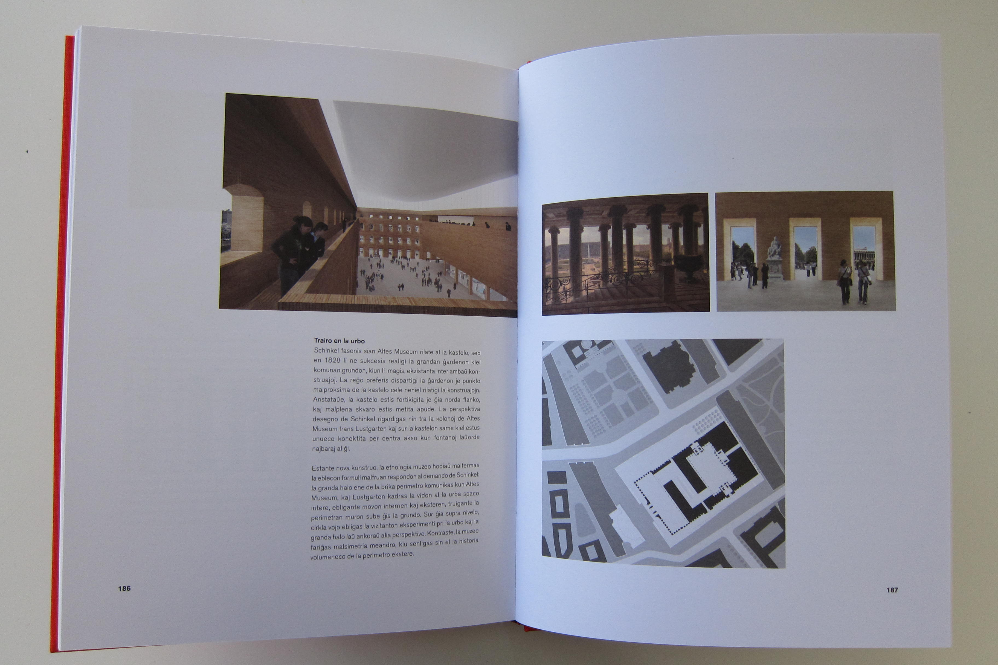

Kuehn-Malvezzi chose the international language Esperanto, invented by Polish Doctor Ludwig Lazarus Zamenhof in 1887, as they found interesting similarities between it and modern art and how it is perceived by the general public. So they naturally turned to French translation agency LinguaForce, which offers a wide range of linguistic services with a large number of languages and areas of expertise available.
A highly specialised subject, the field of art and more specifically that of architecture, in a language still not very widespread – although on the up – was a challenge, one particularly appreciated by Philippe Bérizzi, CEO of the LinguaForce translation agency.
“A translation project is of course characterised by a source language and one or several target languages, but that’s not the only criterion. A translator’s skill is first of all expressed by the languages he or she knows, but also by the areas of his or her expertise. You don’t have somebody to whom you have entrusted the translation of a distribution contract or computer software manual translate a chemistry patent or medical report. The role of the translation agency is to find the best profiles available for specific languages and areas of expertise” explains Philippe Bérizzi.

In just a few days LinguaForce was able to form the team of professional translators capable of successfully completing these translations, by tracking down Esperanto-speaking professional translators adept in such a project from the four corners of the earth.

Art is far from being LinguaForce’s only area of expertise. The Rennes agency has established itself on the market as one of the benchmark agencies as far as highly technical translations are concerned, notably in the field of video, patents and Geographical Information Systems (GIS). This work is performed by translators who have developed skills in computing, electronics, mechanics, medicine... More generally, LinguaForce manages a database of more than 2500 translators working in a hundred or so different languages.

Finally, LinguaForce intends to play a significant role in promoting multilingualism by enabling companies to address their clients in their own language. Going one step further, Philippe Bérizzi has adopted a virtually militant approach: for him it is about encouraging the emergence of a genuine linguistic ecology, raising the awareness of the need to protect the planet’s linguistic resources, defending the French language and preserving minority languages. And among them, Esperanto, its advantage as we are reminded lies in how quick it is to learn (10 times quicker than English) which would make it a very profitable alternative as an internal communication language in all companies that develop globally – opening subsidiaries abroad.

About LinguaForce
LinguaForce, a company founded in 2001, has developed a complete range of services aimed at companies looking to give their business an international dimension: translation (technical, legal, commercial...), interpretation (simultaneous, consecutive, by phone), validation of brands globally, subtitling, language training of international teams, etc.
Good at meeting the expectations of companies in a wide range of languages and fields, LinguaForce has several hundreds of direct or indirect clients including Air Liquide, BNP Paribas, Bretagne Développement Innovation, Cybergun, Dassault Systèmes, DHL Freight, Ergobaby, GiSmartware, Harris, Mondial Assistance, Puma, Saint-Cyr Coëtquidan, Renault, SC Johnson, Sephora, Société Générale, Technicolor, Triballat…

About Kuehn-Malvezzi
Kuehn Malvezzi was founded by Simona Malvezzi, Wilfried Kuehn and Johannes Kuehn in Berlin in 2001. Their museum and exhibition architecture includes Documenta11, the Julia Stoschek Collection, the Friedrich Christian Flick Collection and the Museum Berggruen. Kuehn Malvezzi’s entry for Humboldt-Forum Berlin was awarded with the jury’s special prize and the German critics’ prize 2009. They were exhibited in the German Pavilion at the 10th Architecture Biennial in Venice 2006.

About Esperanto
Esperanto has become more widespread since it was created at the end of the 19th century and is now spoken by at least two million people over the five continents.
A discreet phenomenon but one on the increase thanks to the Internet, Esperanto is the only manmade language that has survived its creator and is continuing to evolve as a natural language. Recognised by Unesco, it is today one of the languages that can be used in Google Translation and is ranked 27th in the list of Wikipedia languages, which even places it before several official languages of the European Union. In the field of literature, a new book in Esperanto is published practically every day. Most major cities in Europe and around the world have an Esperanto club, and for several years there has been an official Esperanto exam that comes within the common European framework network for languages (CEFR).

Contacts:

LinguaForce  3 boulevard des Trois Croix  FR-35000 Rennes  www.linguaforce.com  Contact: Philippe Bérizzi  +33 (0)2 99 59 73 10  info@linguaforce.com | Kuehn-Malvezzi  Heidestrasse 50  D - 10557 Berlin  www.kuehnmalvezzi.com  Contact: Samuel Korn  +49 (0)30 39806800  press@kuehnmalvezzi.com | Universala Esperanto Asocio  Nieuwe Binnenweg 176  NL-3015 BJ Rotterdam  www.uea.org  Contact: Philippe Debrix  +33 (0)9 50 85 04 04  philippe.debrix@gmail.com

Web link: http://www.linguaforce.com/presse/PressReleaseLF2012.htm

